Cellular Structure of a Typical Animal Cell

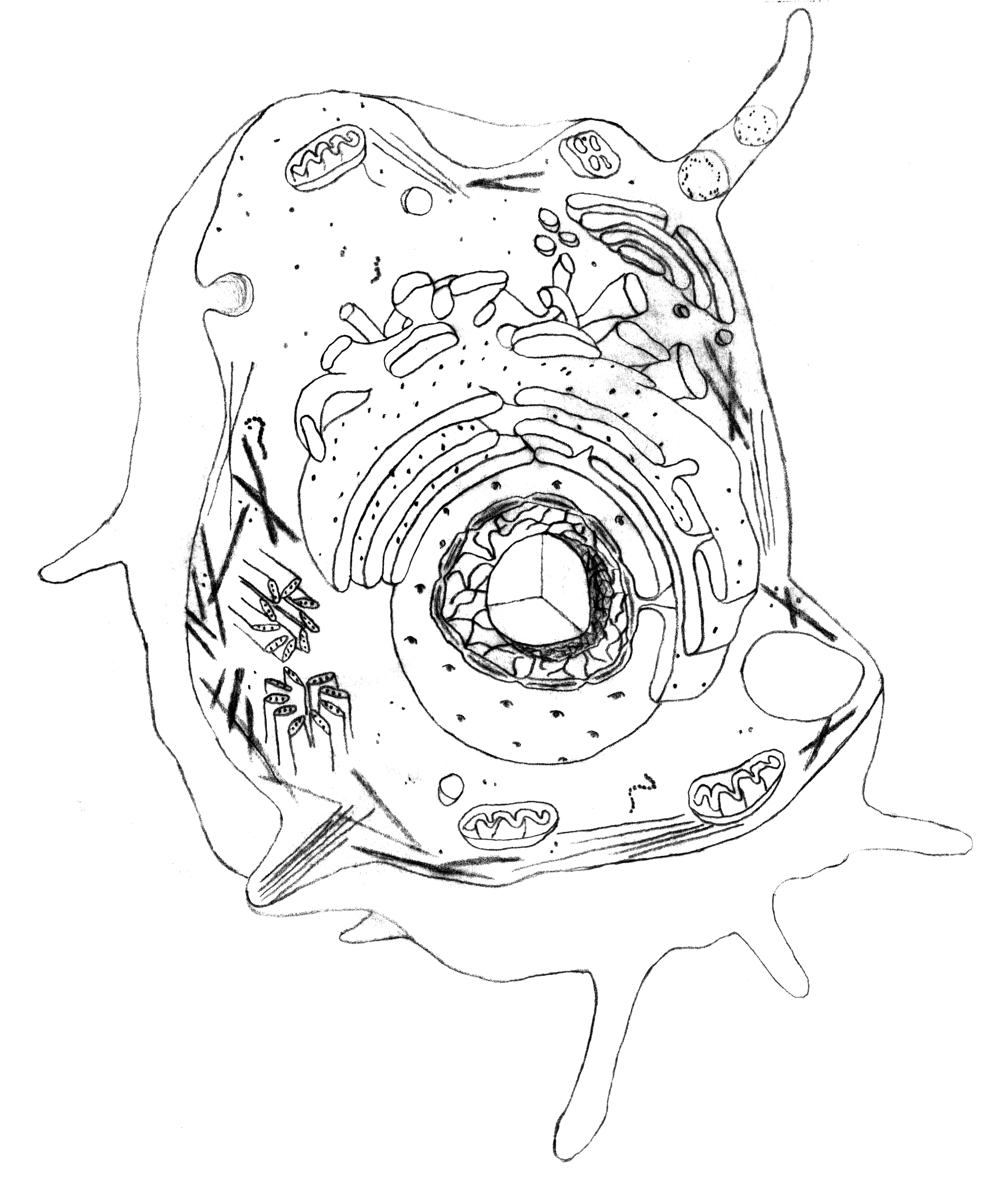
mitochondrion
lysosome
cell membrane
vesicle formation
cillium
basel body
Golgi apparatus
smooth ER (endoplasmic reticulum)
ribosome
nuclear envelope
rough ER
nucleolus
nucleus
vacuole
chromatin
cytoplasm
actin filaments
microtubules
centriole
polysome

Cell Membrane

The phospholipid bilayer, which the cell membrane is an example of, is composed of various cholesterol, phospholipids, glycolipids and proteins. The cell membrane separates the contents of the cell, the cytoplasm, from the surrounding environment. The membrane also compartmentalizes the cell into specific regions. A membrane also encloses organelles. Below is an example of a simple phospholipid bilayer.

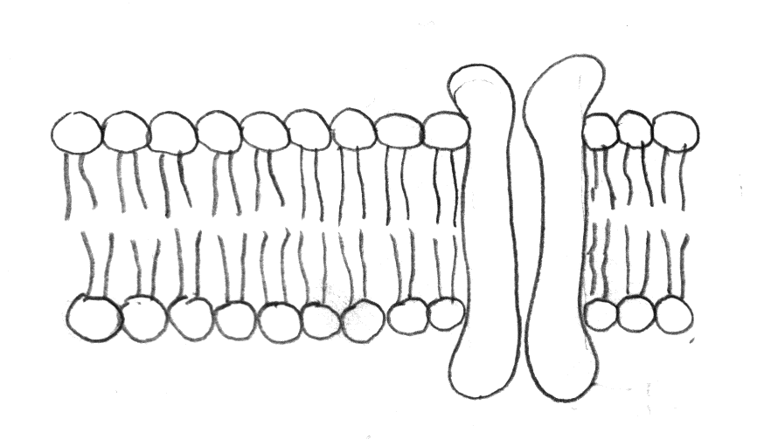
phospholipid bilayer
protein molecule

There are smaller molecules between the phospholids, such as Cholesterol, which helps to give rigidity or stability to the membrane. The phospholipids are the hydrophilic circles with hydrophobic tails. And since most of the cell and area surrounding the cell is made up of water, these fatty acid tails always 'push' away from the water. Causing either a bilayer as above or a 'micelle', which is a single layer circle of phospholipids with the tails pointing in.

There are different are 10 main types of lipids in cell membranes. Each type of cell or organelle will have a differing percentage of each lipid, protein, or carbohydrate.

Mitochondria

Mitochondrion is the singular form of mitochondria. The mitochondria’s major role is ATP (adenosine triphosphate) production in the eukaryotic cell. These are mobile and flexible organelles, although in some cells they tend to stay in a fixed position. The fixed position is especially true of cells or locations in cells where there will be a need for a high amount of ATP production, such as, near flagella or between myofibrils of muscle. Mitochondria are also self-reproducing; they have their own circular DNA.

A double membrane bound mitochondria. The inner membrane is folded to form little shelves called cristae, which project into the matrix, an inner space filled with a gel-like fluid.

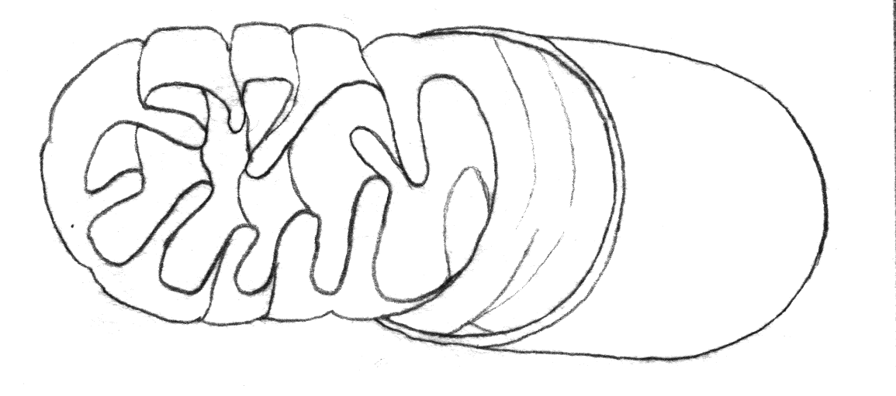
outer membrane
inner membrane
cristae

matrix
double membrane
Mitochondria, often called the powerhouse of the cell, convert the chemical energy of glucose products into the chemical energy of ATP molecules. During this process, mitochondria consume oxygen and give off carbon dioxide and water. ATP production occurs in the cristae and the matrix is responsible for breaking down glucose products. This process is called aerobic cellular respiration, the formula for which is generalized as: carbohydrate + oxygen → carbon dioxide + water + energy (ATP)

Smooth & Rough Endoplasmic Reticulum

The Endoplasmic Reticulum (ER) is responsible for a wide range of tasks, including the biosynthesis of: lipids for constructing new membranes, proteins (via ribosomes) and complex carbohydrates. The ER membrane typically makes up more than half of the total membrane in the cell and is located between the nucleus and the Golgi apparatus. This means that there is 2 membranes between the nucleus and the Golgi Apparatus, the outside ER membrane and the nuclear membrane (This is because the ER is continuous with the outer nuclear membrane). However, there are 2 membranes between the Golgi apparatus and the ER, as a result there is a LARGE amount of transfer between the two organelles, which suggests there is probably transport occurring through transport vesicles (shown below).

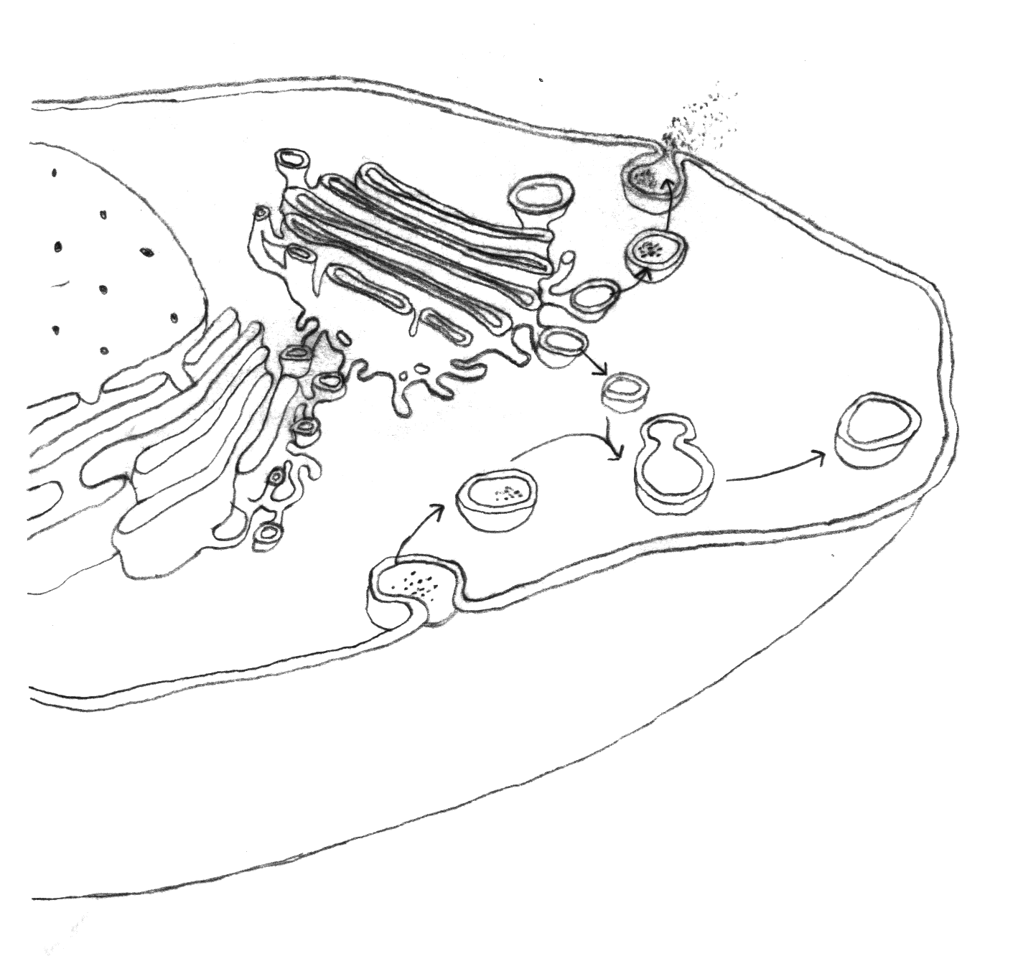
secretion
outer face
transport vesicle
secretory vesicle
vesicle formation
pinocytosis
inner face
cell membrane
rough ER
smooth ER
Golgi aparatus
If ribosomes are attached to the ER, it is called the rough ER; if not, it is called the smooth ER. Both are involved in the synthesis and modification of macromolecules.

The smooth ER produces different molecules in different cells. In the liver it is responsible for detoxification of drugs. Vacuoles, called peroxisomes are often attached to the smooth ER and contain enzymes capable of detoxifying drugs.

The rough ER specializes in protein synthesis. Ribosomes attached to the rough ER make proteins for export from the cell. These proteins enter the lumen of the rough ER, where they can be modified, after which they are transported to a small vesicle that transports the proteins to the Golgi apparatus, where it undergoes further processing.
Ribosomes

The Ribosome is made of of two subunits called a large subunit and a small subunit, each of which has its own particular mix of rRNA and proteins. Ribosomes are about 25 nm in diameter. The subunits are made up of ribosomal RNA (rRNA) and ribosomal proteins. Ribosomes come in to basic varieties, which is defined by whether they are bound to the Endoplasmic Reticulum or not; hence the name 'free ribosomes' for the ribosomes that "float" in the cytosol. The role of ribosomes in the rough ER is to manufacture proteins and when they are arranged in a functional group they are called a polysome.

Golgi Bodies

The Golgi apparatus is a membrane-bound structure with a single membrane. It is actually a stack of membrane-bound vesicles that are important in packaging macromolecules for transport elsewhere in the cell. Numerous smaller vesicles containing those packaged macromolecules surround the stack of larger vesicles. The enzymatic or hormonal contents of lysosomes, peroxisomes and secretory vesicles are packaged in membrane-bound vesicles at the periphery of the Golgi apparatus.

Golgi Bodies can be considered the final packaging location for proteins and lipids. Each Golgi body consists of flattened membrane sacs. It is within the flattened membrane sacs that enzymes ready these proteins and lipids for shipment to specific locations. Vesicles form at the final region of a Golgi body when parts of the membrane begin to bulge. These vesicles then break away, via exocytosis, for the transport of these proteins and lipids to their final destination. Within the Golgi body (or Golgi apparatus), these proteins and lipids are labelled with sequences of molecules (an address) that tell the body where these products should be delivered.

Vesicles

Vesicles have a simple structure, they are liquid filled sacs surrounded by a single membrane. When viewed through a microscope they closely resemble vacuoles, lysosomes, and peroxisomes. Some vesicles are formed by pinching off from the Golgi apparatus.

Vesicles are the shipping containers within cells. They are used to package liquids containing a wide variety of substances and carry these materials to other parts of the cell or to the outside of the cell. Vesicles also form around materials (liquid or solid) that are brought into the cell. Vesicles that carry material out of the cell are called exocytotic vesicles and those that bring material into the cell are called endocytotic vesicles.

Vacuoles

A vacuole is a membrane-bound sac that plays roles in intracellular digestion and the release of cellular waste products. In animal cells, vacuoles are generally small.

Vacuoles tend to be large in plant cells. When a plant is well watered, water collects in cell vacuoles producing rigidity in the plant. Without sufficient water, pressure in the vacuole is reduced and the plant wilts.

Lysosomes

Lysosomes (common in animal cells but rare in plant cells) contain hydrolytic enzymes necessary for intracellular digestion. In white blood cells that eat bacteria, lysosome contents are carefully released into the vacuole around the bacteria and serve to kill and digest those bacteria. Uncontrolled release of lysosome contents into the cytoplasm can also cause cell death (necrosis).
Lysosomes have various roles. They are active in recycling the cell's organic material and in the intracellular (intra-) digestion of macromolecules. In addition, in many organisms, lysosomes are involved in programmed cell death.

In humans, a variety of inherited conditions can affect lysosomes. These defects are called storage diseases and include Pompe's disease and Tay-Sachs disease. People with these disorders are missing one or more of the lysosomal hydrolytic enzymes.

Nuclear Envelope

The nuclear envelope has two membranes, each with the typical unit membrane structure. They enclose a flattened sac and are connected at the nuclear pore sites. The outermost membrane is continuous with the rough endoplasmic reticulum (ER) and has ribosomes attached (see figure to the left). The space between the outer and inner membranes is also continuous with rough endoplasmic reticulum space. It can fill with newly synthesized proteins just as the rough endoplasmic reticulum does. The nuclear envelope is enmeshed in a network of filaments for stability.

Nucleus

The nucleus is the most obvious organelle in any eucaryotic cell. It is a membrane-bound organelle and is surrounded by a double membrane. It communicates with the surrounding cytosol via numerous nuclear pores.

Within the nucleus is the DNA responsible for providing the cell with its unique characteristics. The DNA is similar in every cell of the body, but depending on the specific cell type, some genes may be turned on or off - that's why a liver cell is different from a muscle cell, and a muscle cell is different from a fat cell. When a cell is dividing, the DNA and surrounding protein condense into chromosomes that are visible by microscopy.

Nucleolus

The Nucleolus is probably the most striking and well studies sub-compartment of the eukaryotic nucleus that, in addition to its role in ribosomal RNA biogenesis, has been implicated in control of cellular survival and proliferation. Mammalian nuclei usually contain between 1-4 nucleoli, which together can take up as much as a third of the nuclear volume. As a structure the nucleolus consists of three morphologically distinct components: the fibrillar centres (FC), which contain hundreds of rRNA genes in tandem arrays found at several chromosomal loci (termed nucleolar organising regions (NORs) ; the dense fibrillar component (DFC), which contains actively transcribing rRNA genes and nascent rRNA transcripts; and the granular component (GC), which is the site of late processing events in the

Ribosomal RNA is necessary to the formation of small ribosomes, which function in the cytoplasm.

Chromosomes

Chromatin is the genetic material that contains the blueprint of the cells structure and functional capabilities. Chromatin is comprised of chromosome strands made of DNA. Chromatin condenses into rod-like structures called chromosomes at the time of cell division. Chromatin and therefore chromosomes contain DNA, which is responsible for directing protein synthesis. A cell’s proteins help determine its structure and function.

